|  |  |
| --- | --- |
| Date | 10 November 2022 |
| Team ID | PNT2022TMID01164 |
| Project Name | Project - Gas Leakage monitoring & Alerting system for Industries |

Develop

Aim: Develop the web application using Node-RED Steps Followed:

* Opened a Node-RED project

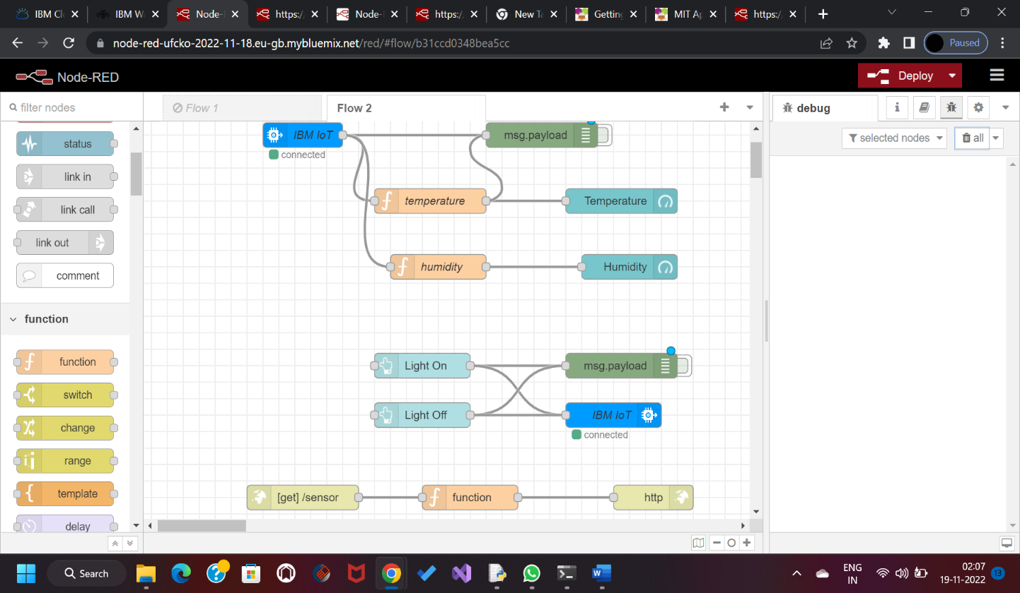

* Added code to get child location in python

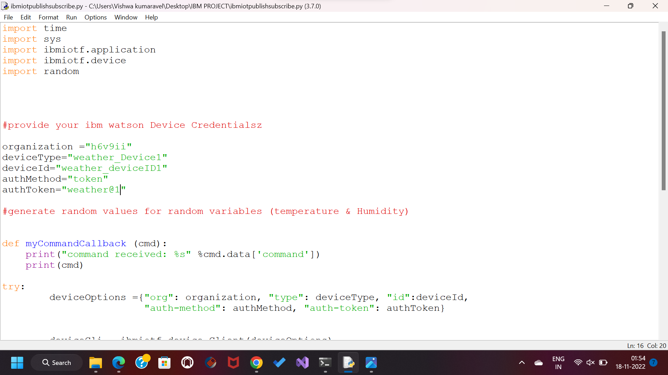

Editing the HTTP Request URL

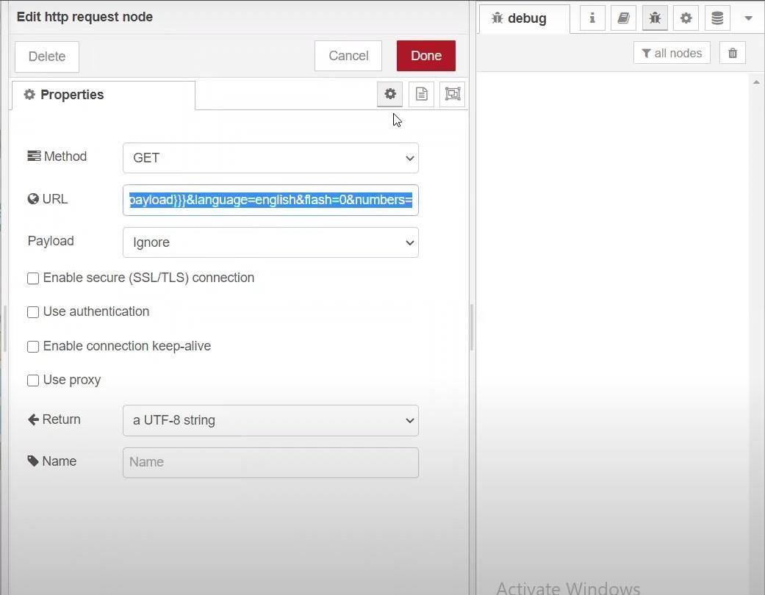

* Python script sending requests to IBM Cloud

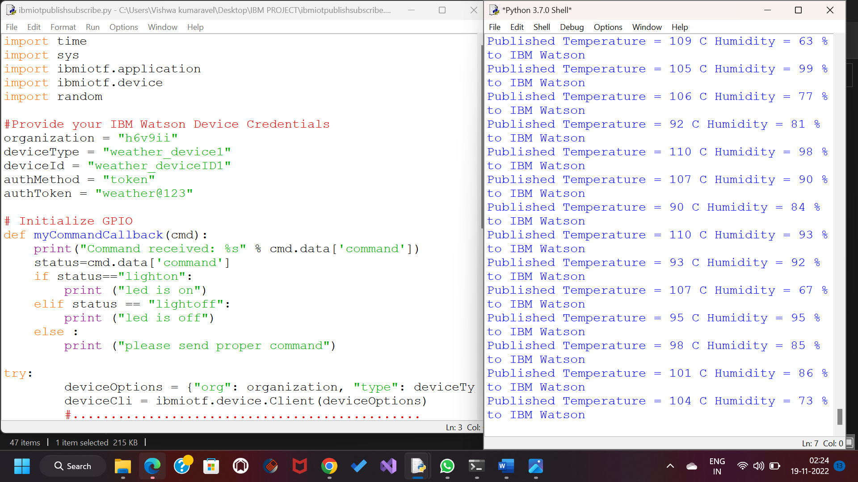

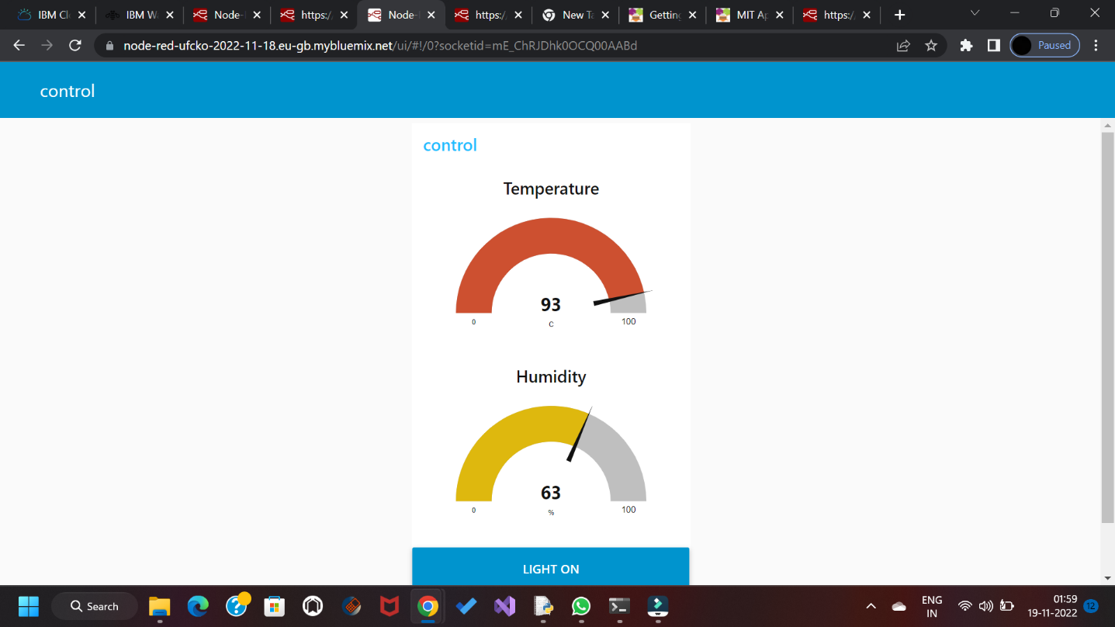

Result: Successfully developed the web application using Node-RED